**Madame Tussauds Museum London**

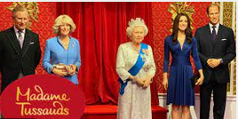

**Address:** Marylebone Road



**Opening Times:** 10 am - 3pm

**Tickets:** adult 26 £/student 16 £

**Buckingham Palace**

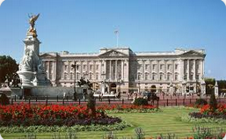

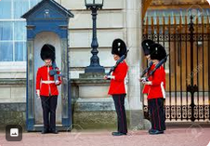

**Address:** London SW1A 1AA



**Opening Times:** 9.45 am - 6.30 pm

**Tickets:** from 17,21 £ person